Mounting board

The mounting board has a hole for a bolt through the center that allows for mounting to the bracket. It also has holes each of the 10 pairs of solar panel wires. The top portion has 4 places for the light sensors, which are separated by a plastic divider.

# Single solar panel (10 total)

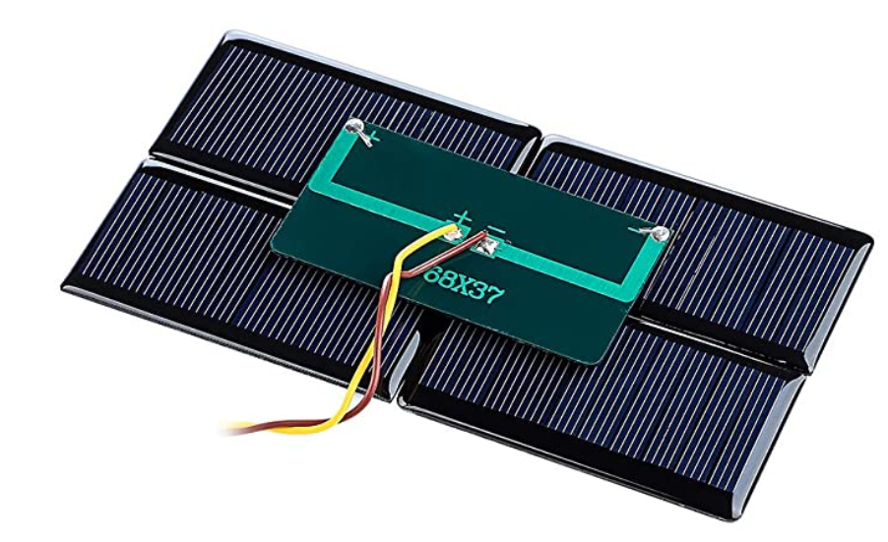

Dimensions: 68 mm x 37 mm

Notes

* wires are soldered in the middle of board
  + approx. 6 mm x 4 mm hole required to run wires behind
* solar panels arranged in 2 x 5 array

# Light sensors (4 total)

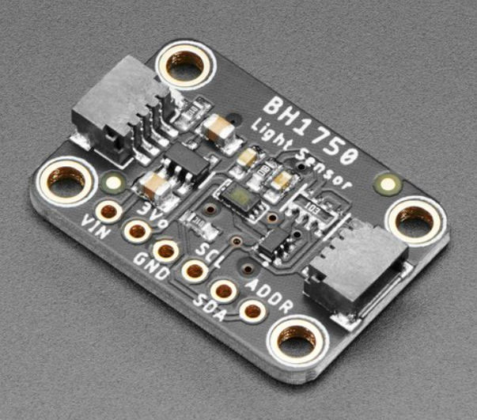

Dimensions: 25.33mm x 17.7mm x 4.5mm

Notes

* the sensors use 15 cm qwiic JST to male cables

Base (top half)

# Vertical servo bracket mount hole

Base (bottom half)

# 18650 battery holder

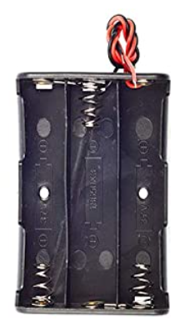

Dimensions: 74.3 mm x 19.812 mm x 18.034 mm

Screw in the center to attach to the bottom of case

# Solar charge controller

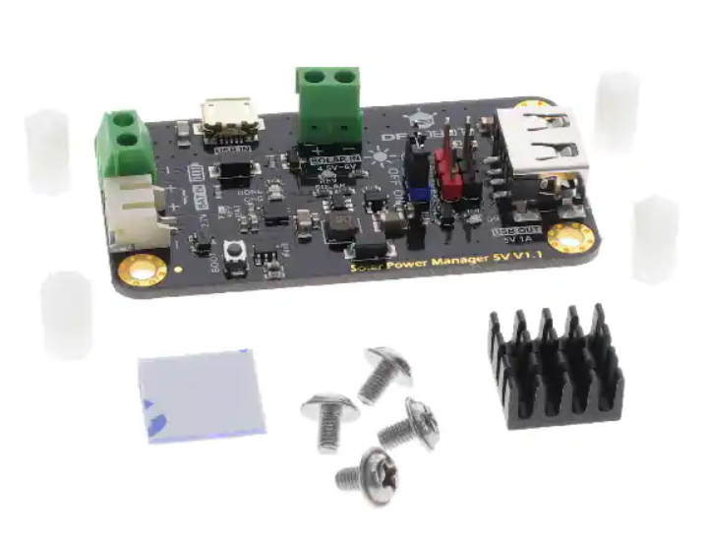

Dimensions: 33.0 mm x 63.0 mm

# STM32 nucleo board

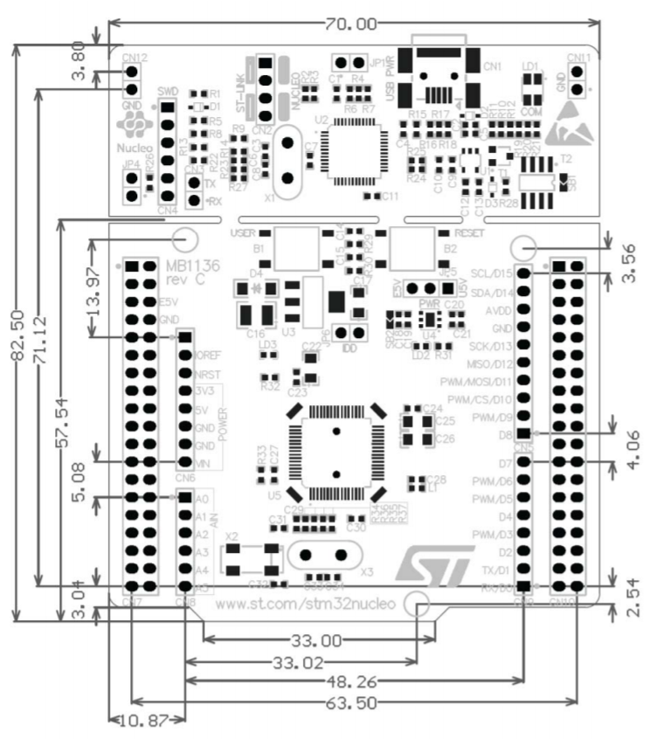

Dimensions: 82.5 mm x 63.5 mm